# Manual Testing Project

## Project Introduction

## Understanding and Explore the Functionality(FRS)

## Test Plan

## Writing Test Scenarios

## Writing Test Cases and Reviews

## Environment Setup and Build Deployment

## Test Execution

## Bug Reporting and Tracking

## Sanity Testing, Re-Testing and Regression Testing

## Test Sign Off

# Two parts are there for e-commerce Application.

# Front End -Internet(public)

## Everybody will be able to access the application through internet.

# Back End – Intranet(only within organization(admin))

## This application can only be accessed by admin.

## Who will place the product, delete the product, who will process the payment request, who will refund and collect the product.

## Registered user also maintained in backend.

## As manual tester we are going to work with Front End Application.

# FRS

## Contains overview, requirements, mockup screens and respective description of the pages.

## In FRS, we describe the particular functionalities of every single page in detail from start to end.

# BRS

# SRS

# Test Plan

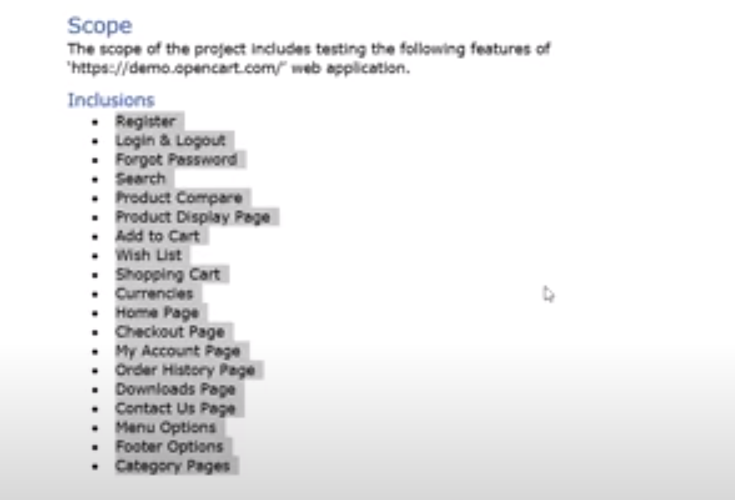

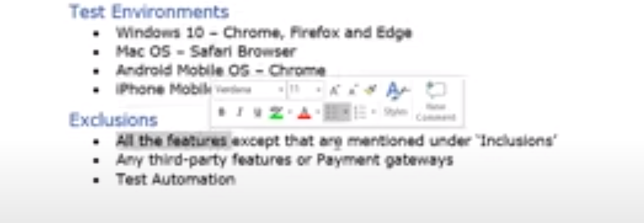

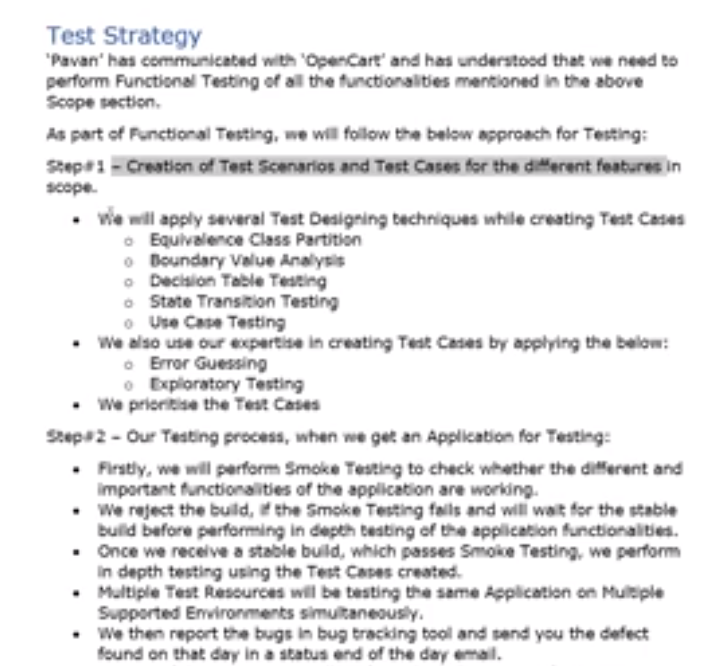

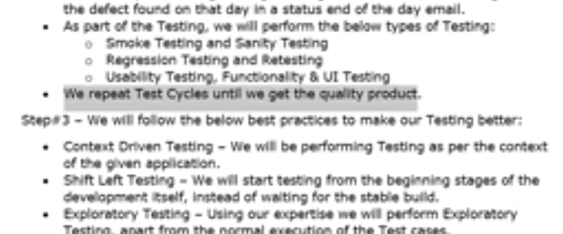

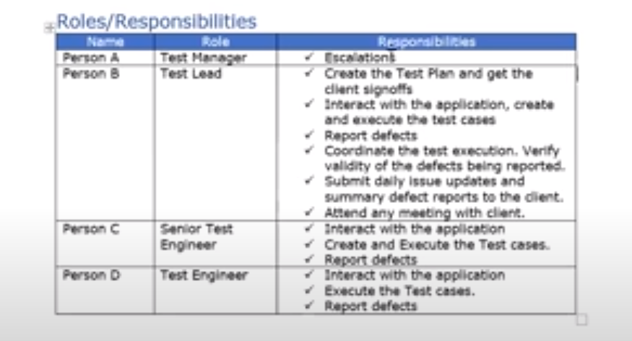

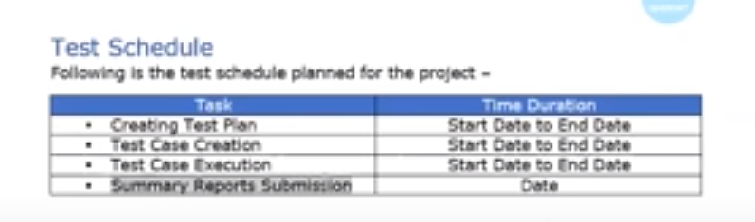

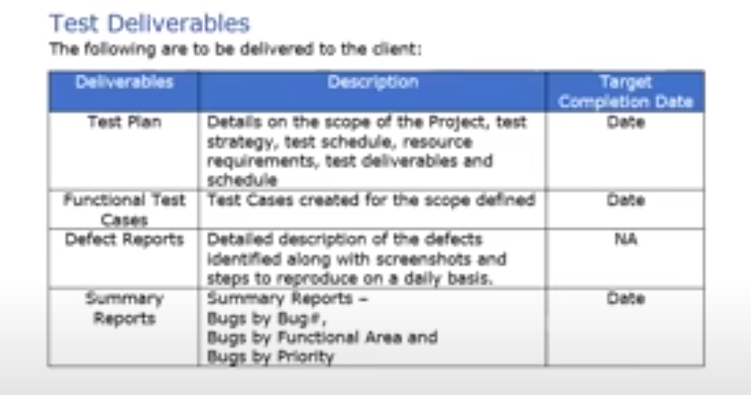

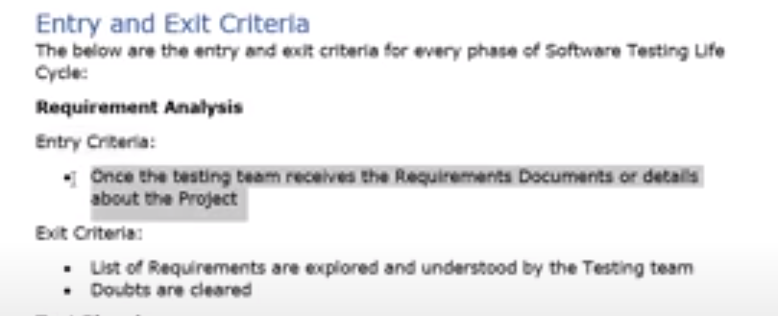

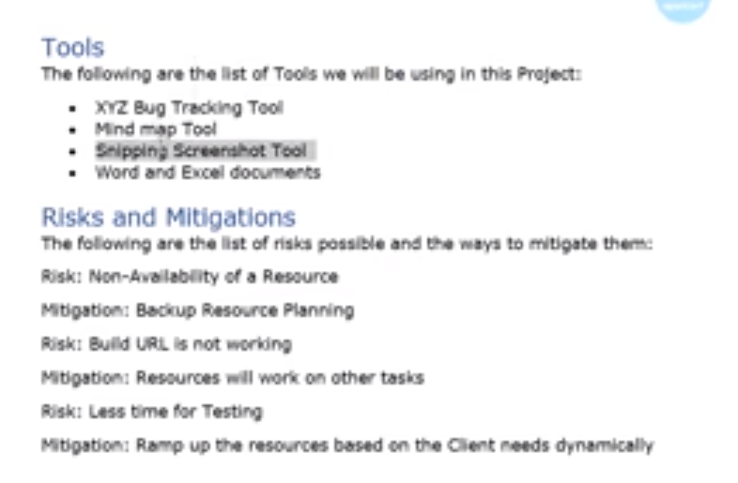

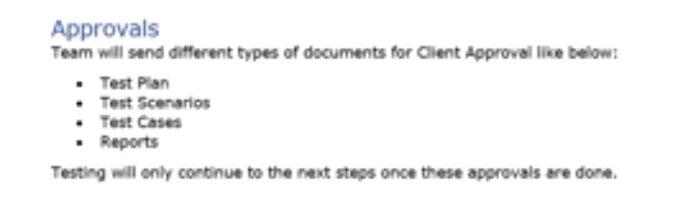

# Test Scenarios

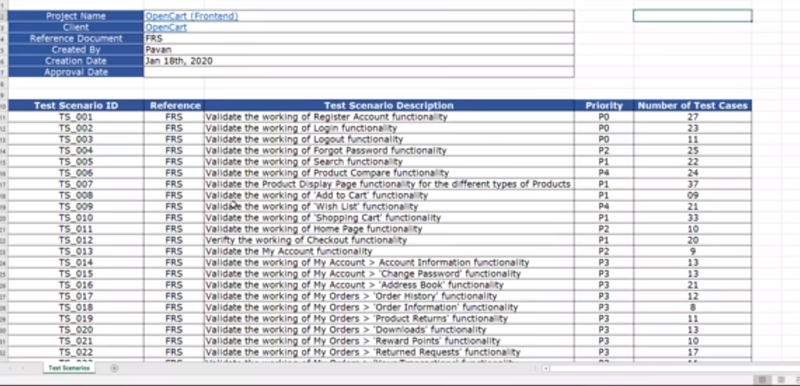

# Test Cases

# First sheet

# Version History

## It tells how many times we have updated this document.

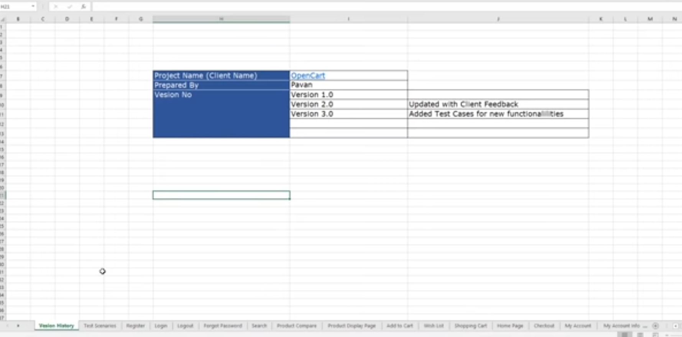

# Second Sheet

# Test Scenarios

## Contains multiple Test Cases

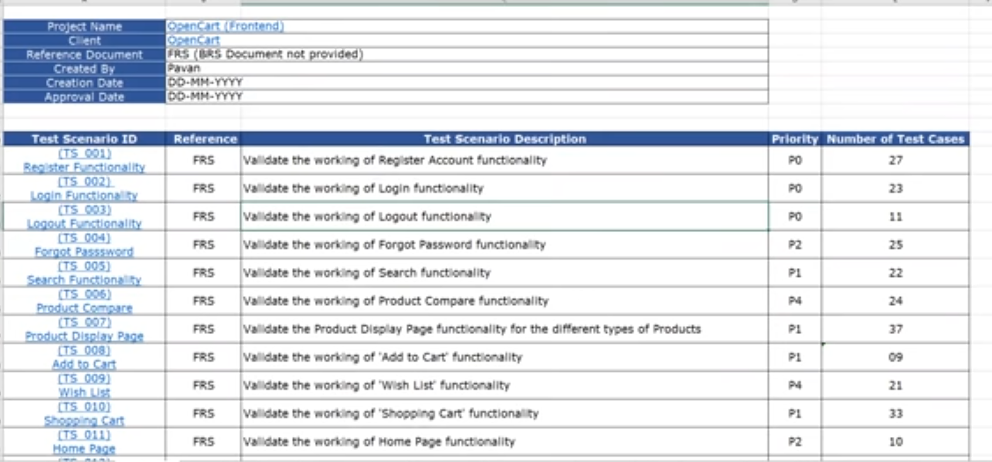

# From Sheet 3

# Test Cases

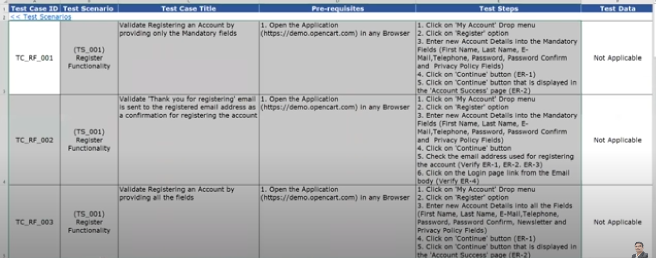

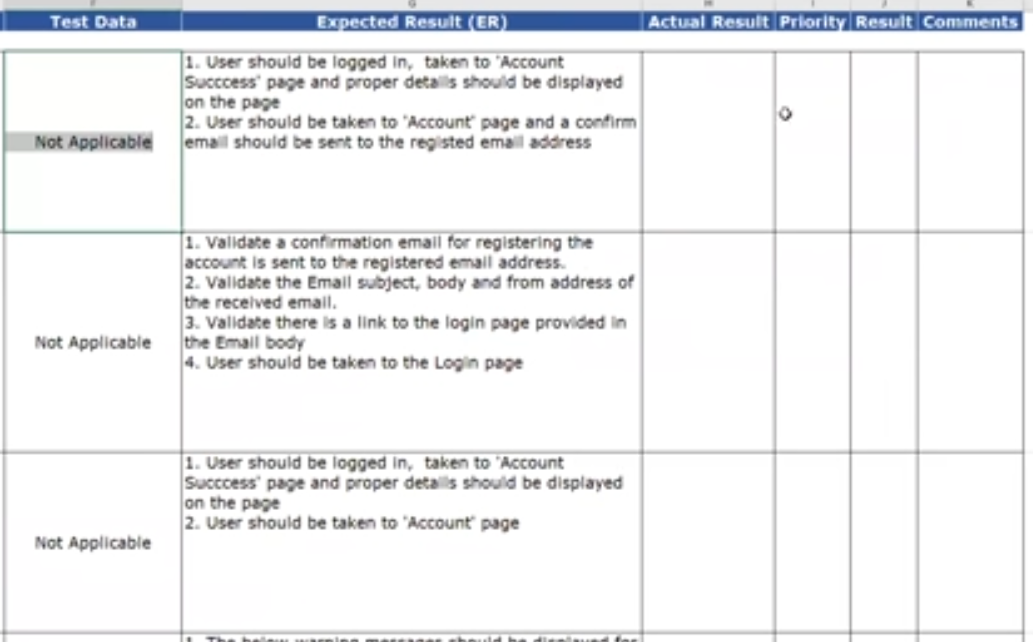

# Once the Test case is done, we have to prepare the traceability matrix

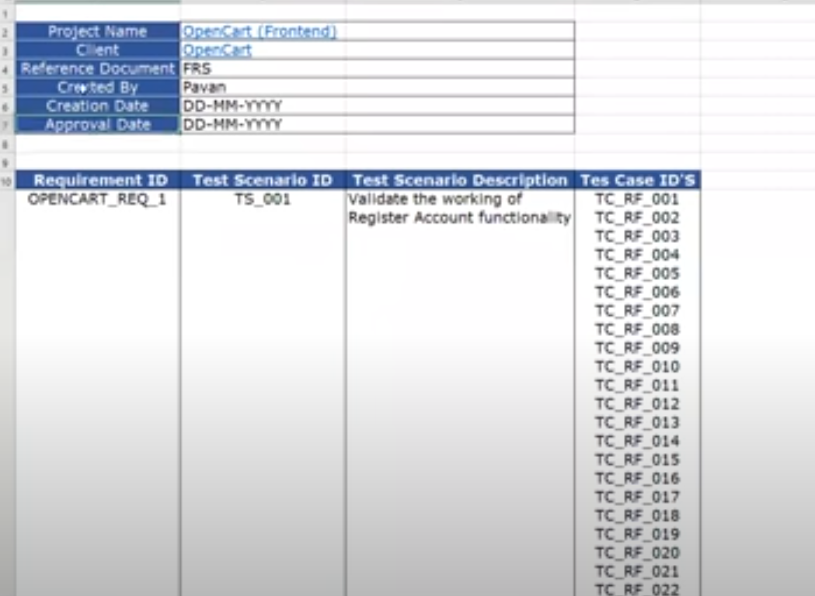

# Deployment

## Whatever build we get from the developer we install it in our Test Environment.

## To deploy the application, we need the server.

## Developer provides release notes along with the build.

# Release Notes

## It contains how we must deploy(step by step installation) the applications and what the features developed and what are the bug they fixed in that build.

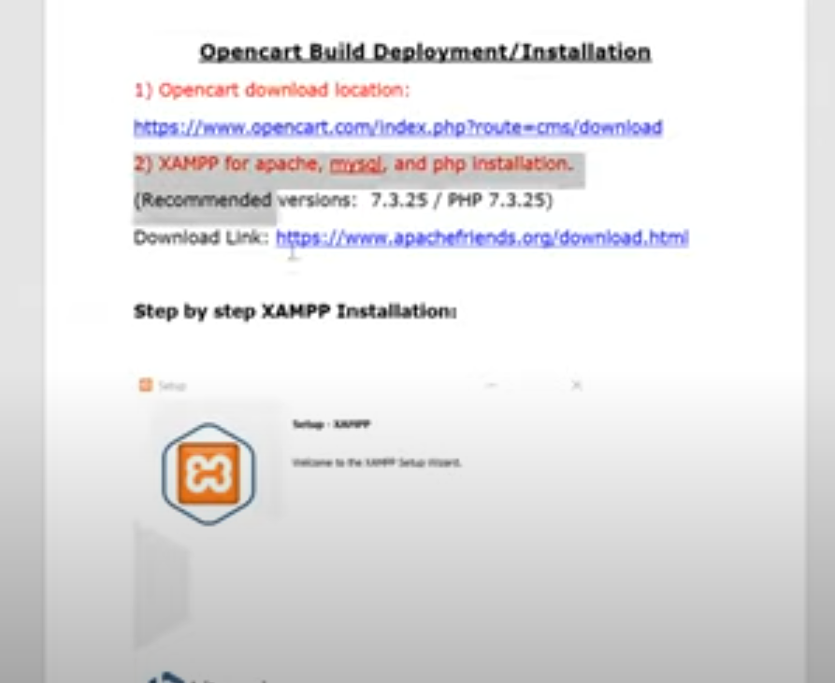

## Download the application from given URL.

## Create the database from URL.

## Establish connection between web application and database.

